Q.1 - Sorting a Numeric Array
Write a Java program to sort a numeric array.
Instructions:
- Create a Java program that can sort an array of numeric values.
- You should decide whether to use ascending or descending order for sorting.
- You can use any sorting algorithm you are comfortable with (e.g., bubble sort, insertion sort, etc.).
- Make sure to prompt the user to input the array or define an array in the program itself for sorting.
- Display the sorted array as output.
- Test your program with different arrays to ensure it sorts correctly.
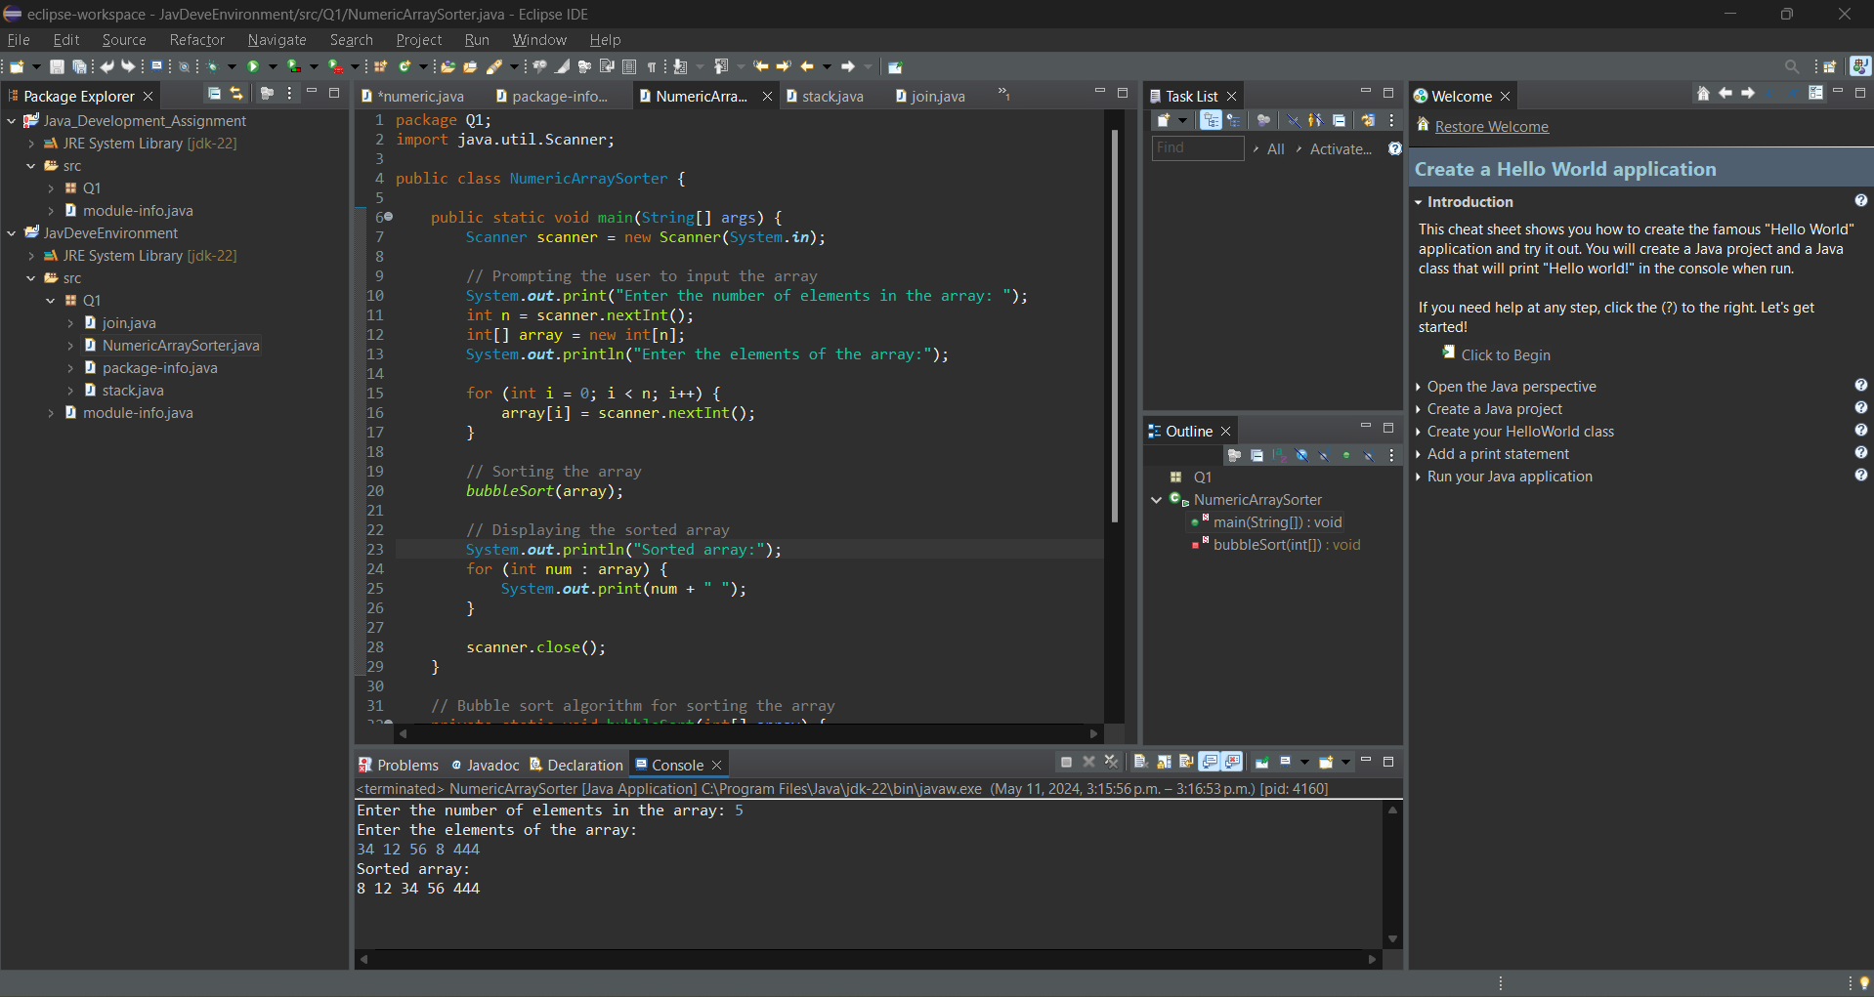
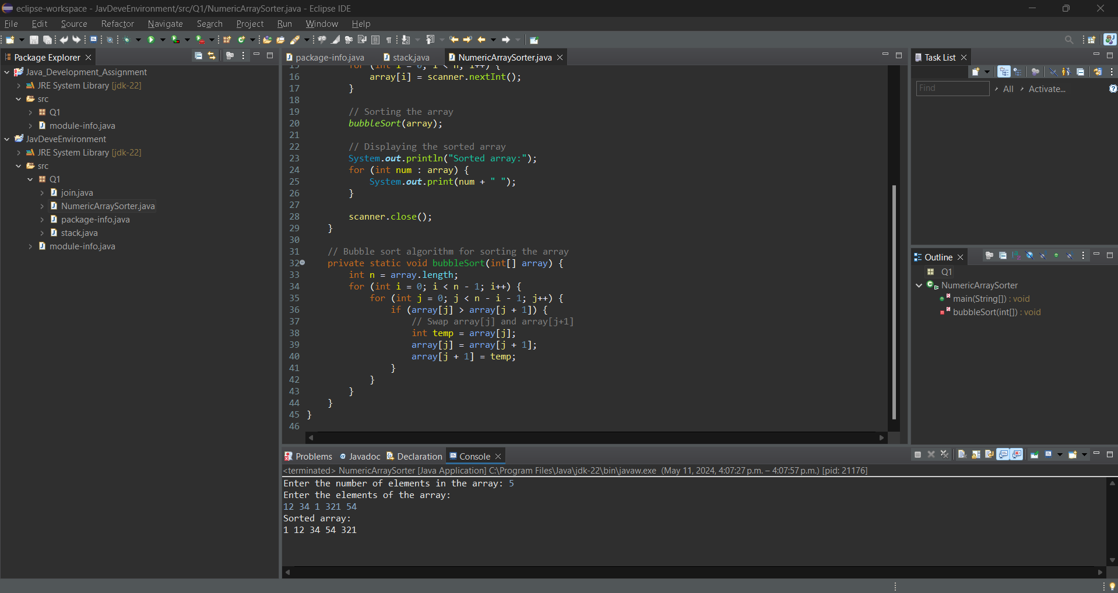

This program takes an array of numbers, sorts them using the bubble sort method, and then displays the sorted array. It's a simple yet effective way to organize a list of numbers.

Q.2 - Implementing a Stack as an Array
Implement a stack data structure using an array. Write a program to check whether the number of open parentheses is equal to the number of closed ones in an input string.
Example:
Input: ((()))
Correct input
Input: (()
Incorrect input
Instructions:
- Create a Java program that implements a stack using an array.
- The program should have a function to check whether a given input string has balanced parentheses.
- For each open parenthesis '(', push it onto the stack.
- For each close parenthesis ')', pop an open parenthesis from the stack.
- After processing the entire input string, if the stack is empty, the input has balanced parentheses. Otherwise, it's unbalanced.
- Display the result (either "Correct input" or "Incorrect input") based on the balance check.
- Test your program with various input strings to verify its correctness.

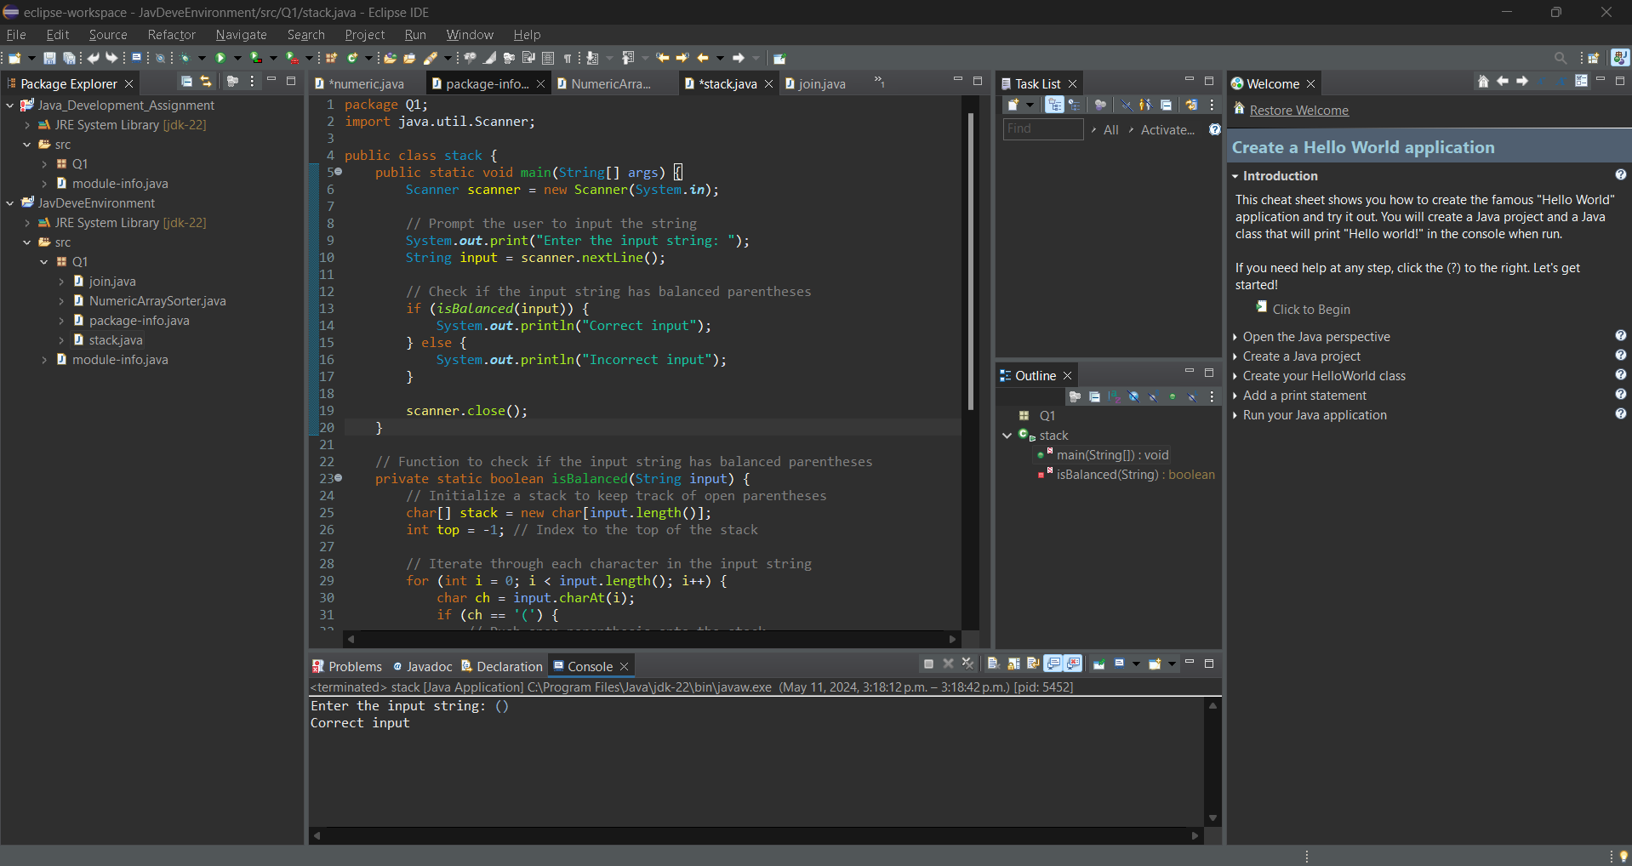
Displays the result that the input has balanced parentheses.
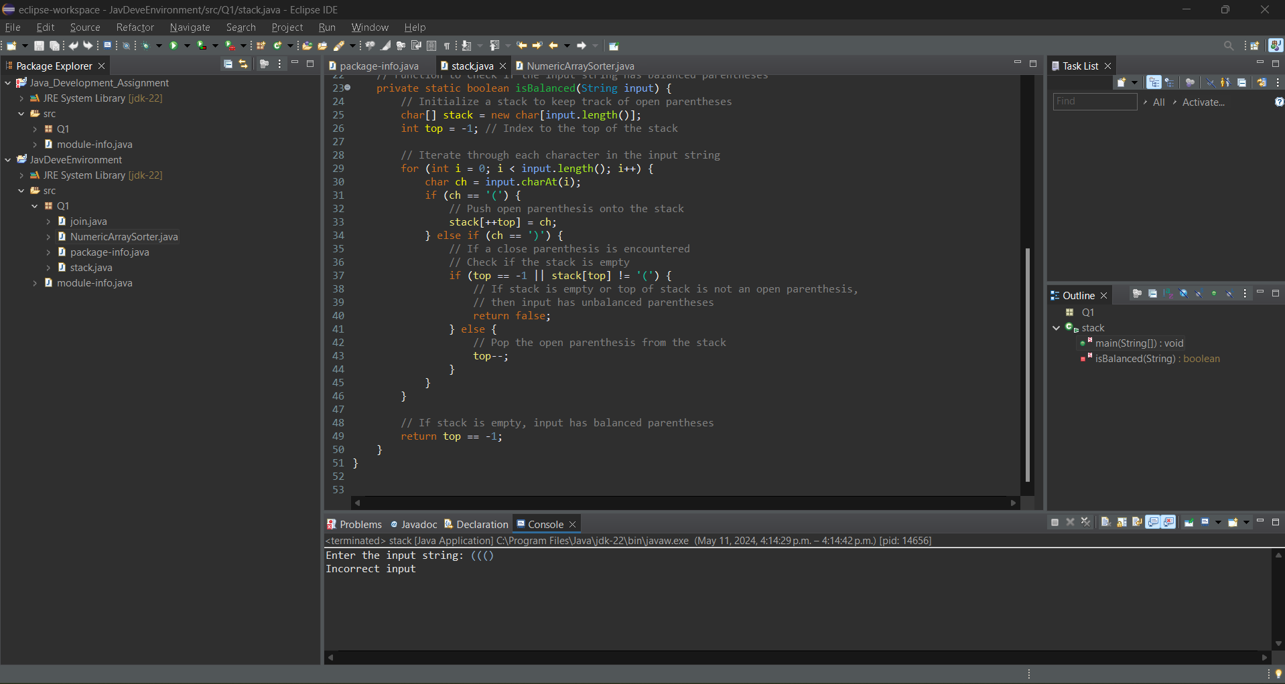
Displays the result that the input has unbalanced parentheses.

This program effectively uses a stack data structure implemented with an array to check whether the given input string has balanced parentheses. It follows the steps of pushing open parentheses onto the stack and popping them when encountering closed parentheses, then verifying the balance of parentheses and displaying the result accordingly. Testing with various input strings ensures the program's correctness and robustness.

Q.3 - Joining Two Array Lists
Write a Java program to join two Array Lists.
Instructions:
- Create a Java program that joins two Array Lists into a single Array List.
- You can either prompt the user to input two Array Lists or define two Array Lists in the program.
- Use the appropriate method to combine the two Array Lists.
- Display the resulting combined Array List.
- Test your program with different sets of Array Lists to ensure it joins them correctly.

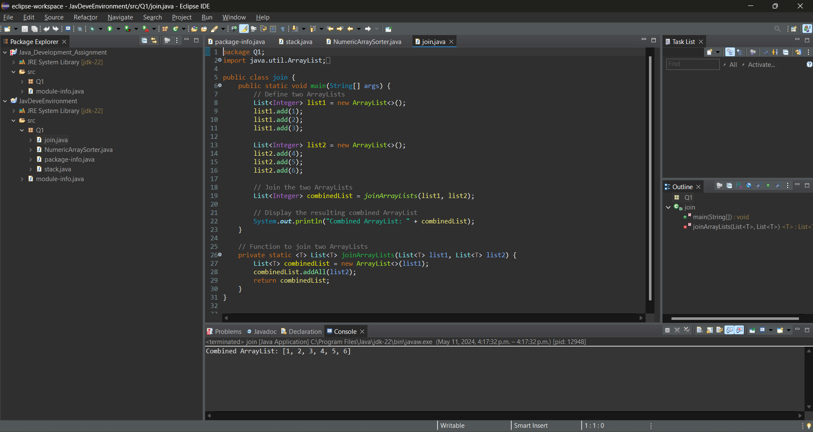
This program efficiently combines two ArrayLists into a single ArrayList, allowing for flexibility in input methods and ensuring correctness through thorough testing.

